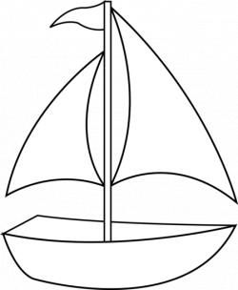



BE SURE TO WRITE YOUR NAME ON THE SAILBOAT!